LAB 01 BASIC DEVICE CONFIGURATION and CLI NAVIGATION

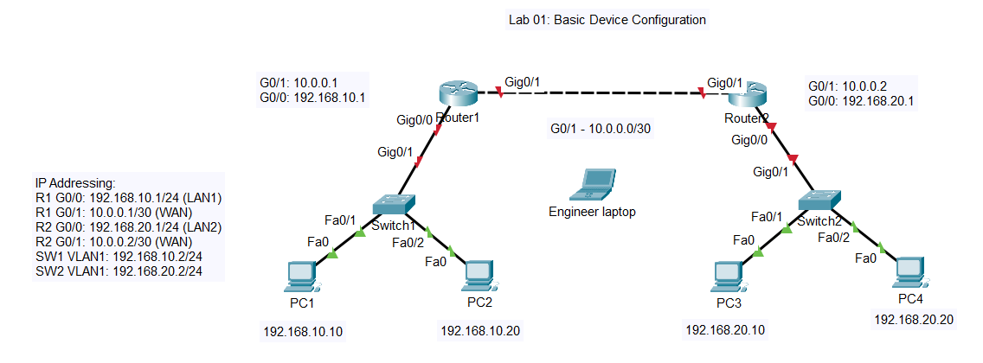

STUDENT INSTRUCTIONS
================================================================================

PART 1: CLI NAVIGATION
----------------------------------
1. Connect to R1 via console cable
2. Enter User EXEC mode - note the prompt symbol
3. Enter Privileged EXEC mode - what command is used? Note the new prompt
4. Enter Global Configuration mode - what command is used? Note the new prompt
5. Enter Interface Configuration mode for G0/0
6. Return to Privileged EXEC mode using the "end" command
7. Use the "?" to explore available commands at each level

PART 2: CONFIGURE R1
---------------------------------
1. Configure the hostname as "R1"
2. Configure a message-of-the-day banner with the text:
"Authorized Access Only! Disconnect Immediately if Unauthorized!"
3. Configure an enable secret password: "class"
4. Configure console line 0:
- Password: "cisco"
- Require login
- Enable logging synchronous
5. Configure VTY lines 0-4:
- Password: "cisco"
- Require login
6. Configure interface GigabitEthernet0/0:
- IP address: 192.168.10.1/24
- Description: "LAN Connection to SW1"
- Enable the interface
7. Configure interface GigabitEthernet0/1:
- IP address: 10.0.0.1/30
- Description: "WAN Link to R2"
- Enable the interface
8. Configure a static route to reach the 192.168.20.0/24 network via 10.0.0.2
9. Configure User YouTube secret Skillnuggets - examine the password / privilege options
10. Save the configuration to NVRAM

PART 3: CONFIGURE R2

1. Configure the hostname as "R2"
2. Configure a message-of-the-day banner with the same text as R1
3. Configure an enable secret password: "class"
4. Configure console line with password "cisco" and login required
5. Configure VTY lines 0-4 with password "cisco" and login required
6. Configure interface GigabitEthernet0/0:
- IP address: 192.168.20.1/24
- Description: "LAN Connection to SW2"
- Enable the interface
7. Configure interface GigabitEthernet0/1:
- IP address: 10.0.0.2/30
- Description: "WAN Link to R1"
- Enable the interface
8. Configure a static route to reach the 192.168.10.0/24 network via 10.0.0.1
9. Configure User YouTube secret Skillnuggets - examine the password / privilege options
10. Save the configuration to NVRAM

PART 4: CONFIGURE SWITCHES

On SW1:
1. Configure hostname as "SW1"
2. Configure enable secret: "class"
3. Configure console password: "cisco" with login
4. Configure VTY password: "cisco" with login
5. Configure VLAN 1 interface with IP 192.168.10.2/24
6. Configure default gateway: 192.168.10.1
7. Configure User YouTube secret Skillnuggets - examine the password / privilege options
8. Save the configuration to NVRAM

On SW2:
1. Configure hostname as "SW2"
2. Configure enable secret: "class"
3. Configure console password: "cisco" with login
4. Configure VTY password: "cisco" with login
5. Configure VLAN 1 interface with IP 192.168.20.2/24
6. Configure default gateway: 192.168.20.1
7. Configure User YouTube secret Skillnuggets - examine the password / privilege options
8. Save the configuration to NVRAM

PART 5: VERIFICATION

1. On R1, use "show ip interface brief" to verify interface status
2. On R1, use "show running-config" to verify your configuration
3. On R1, verify the routing table shows a route to 192.168.20.0/24
4. From R1, ping R2's G0/1 interface (10.0.0.2)
5. From R1, ping R2's G0/0 interface (192.168.20.1)
6. From R1, ping PC3 (192.168.20.10)
7. From PC1, ping PC3 and PC4
8. Telnet from R1 to R2 (10.0.0.2) - verify VTY password works

ASSESSMENT QUESTIONS

1. What is the difference between "enable password" and "enable secret"?
a) Enable password is encrypted, enable secret is not
b) Enable secret uses MD5 encryption, enable password uses Type 7
c) They are the same
d) Enable password is for console only

Answer:

2. What command saves the running configuration to NVRAM?
a) save config
b) copy running-config startup-config
c) write memory
d) Both B and C

Answer:

3. What is the purpose of the "no shutdown" command on an interface?
a) Disables the interface
b) Enables/activates the interface
c) Removes the IP address
d) Reboots the interface

Answer:

4. Which command displays a brief summary of all interfaces and their status?
a) show interfaces
b) show ip interface
c) show ip interface brief
d) show interface status

Answer:

5. What is the subnet mask for a /30 network?
a) 255.255.255.0
b) 255.255.255.240
c) 255.255.255.252
d) 255.255.255.254

Answer:

6. What does the "logging synchronous" command do on a console line?
a) Enables logging to a syslog server
b) Prevents log messages from interrupting your typing
c) Synchronizes the clock
d) Enables debug logging

Answer:

